# ARMS simulation tutorial

Last updated 12/02/2021.

This tutorial provides the files and instructions to replicate the simulations performed in the OpenSim modeling platform, as described in the following publication:

McFarland DC, Binder-Markey BI, Nichols JA, Wohlman SJ, de Bruin M, Murray WM. A Musculoskeletal Model of the Hand and Wrist Capable of Simulating Functional Tasks. IEEE Transactions on Biomedical Engineering

The original simulations were performed in the OpenSim 3.3 release.

**Download simulation files from Simtk.org**

Download the **ARMS Wrist and Hand Model**. In this release you will find the zipped folder **ARMS_Wrist_Hand_Model_3.3*.zip***. Download this folder and use the files in the ARMS_Wrist_Hand_Model_3.3 folder for your simulations and comparisons. Files included in this folder are as follows: this instruction document; a readme document on how to load and use the ARMS models; a Geometry folder containing the bone descriptions; and a folder called ARMS Tutorials. Subfolders of the ARMS Tutorials folder include a CompareResults folder containing .sto and .mot files with the expected outputs of the simulation modules described below and an InputFiles folder containing all required input files for each module.

**Running the models**

|  |  |
| --- | --- |
| There are six different modules: | **Page** |
| **1. Passive forward tenodesis simulation with prescribed wrist flexion/extension**  **Compare to: …\CompareResults\Tenodesis Module\** | **2** |
| **2. Static optimization of sign language letter “O”**  **Compare to: …\CompareResults\Sign Language Module\** | **4** |
| **3. Forward dynamic simulation of maximum grip strength**  **Compare to: …\CompareResults\Forward Grip Module\** | **6** |
| **4. Optimal control theory maximum grip strength** | **8** |
| **5. Forward dynamic simulation of maximum pinch strength**  **Compare to: …\CompareResults\Forward Pinch Module\** | **10** |
| **6. Optimal control theory maximum pinch strength** | **12** |

**Simulation Times:** Set up time to start each simulation is approximately 15 minutes. The expected simulation run times for each module are displayed below:

* Module 1 will take approximately 4 hrs
* Module 2 will take approximately 15 minutes
* Module 3 will take approximately 10 minutes per simulation
* Module 4 will take approximately 10 hrs
* Module 5 will take approximately 5 minutes
* Module 6 will take approximately 2 hrs

# Module 1.Passive forward tenodesis simulation with prescribed wrist flexion/extension

In this module, we perform passive forward simulations with prescribed wrist flexion/extension to illustrate tenodesis grasp and release that occur due to passive forces and torques in the model. This module uses the forward dynamics tool.

1. Once you have downloaded the **ARMS_Wrist_Hand_Model_3.3*.zip***, the models are in the folder:

…\ARMS Tutorials\InputFiles\Tenodesis Module

1. In OpenSim, load a model by going to file->Open Model… and then select“*Tenodesis_Model.osim*”

This model contains prescribed wrist motion from 60˚ flexion to 60˚ extension and then back to 60˚ flexion over the course of 14 seconds.

1. The provided model is set to the correct stating posture. Check the starting posture in the “Coordinates” tab. With the exception of pro_sup and flexion coordinates, all the other coordinates should be set to 0. Pro_sup should be set to 90˚. Due the prescribed wrist motion you will not be able to edit the flexion coordinate, but it should read 60˚. Mcp_flexion, pm_flexion, and md_flexion should be unlocked for digits 2-5 (index, middle, ring, and little fingers). The rest of the degrees of freedom in the model should be locked.
2. Open Forward Dynamics Tool. Tools-> Forward Dynamics…
3. In the Forward Dynamics tool, click the Load… button and load “Tenodesis_Setup.xml”

This file has made the following modifications to the default settings:

1. The time range for the forward simulation was set from 0 to 14 seconds.
2. Checked the Solve for equilibrium for actuator states box.

Once loaded the Forward Dynamics tool should look like the image below: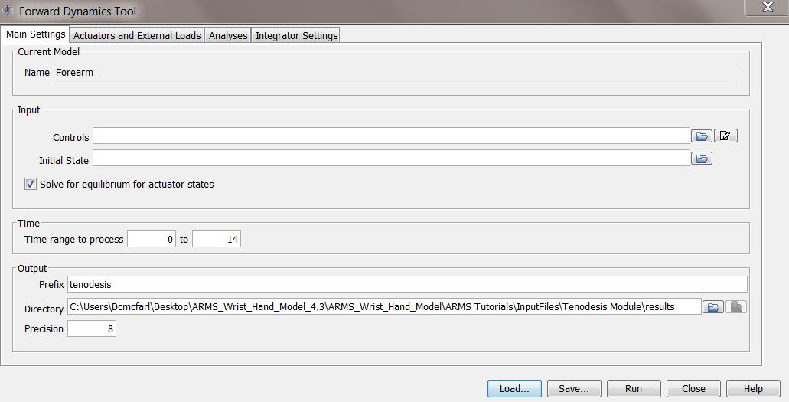

1. Specify Output Directory. Specify the Prefix and Directory for the output to whatever you choose.
2. Click Run to run the simulation.

**Comparison of outcomes**

Outcomes will be stored in a MOT-file. **This file is very large (~1GB) and will take a while for OpenSim plotter to load; if you plot multiple outputs at a time, the OpenSim plotter may display an out of memory error.** Load your results in Plot Tool by clicking “*y-Quantity*”. Select “*Load file*” and browse to your output. Select the joint angle of interest and click *OK*. Compare results for Flexion, xmcp_flexion, xmp_flexion, and xmd_flexion where x is a number ranging from 2 to 5. Click “*x-Quantity*”, choose “*time”* and click *OK*. Click “*Add*” to plot the curve. Without closing the window, click “*y-Quantity*” again and this time load the corresponding comparison output file. Repeat the process above to plot the comparison curves. They should overlay. If you wish to save your plots, right click over the plot and select Export Image… from the menu; this will save the file as a .png image. If you prefer, you can plot the results in MATLAB or Excel. **Compare to:** *…\CompareResults\Tenodesis Module*

# 

# Module 2. Static optimization of sign language letter “O”

In this module, we static optimization simulations on the average kinematics of two participants performing the sign language letter “O”. This module uses the static optimization tool.

1. Once you have downloaded the **ARMS_Wrist_Hand_Model_3.3*.zip***, the models are in the folder:

…\ARMS Tutorials\InputFiles\Sign Language Module

1. In OpenSim, load a model by going to file->Open Model… and then select “Hand_Wrist_Model*.osim*”
2. Open the Static Optimization Tool. Tools-> Static Optimization…
3. In the Static Optimization tool, click the Load… button and load “Sign_Language_Setup.xml”

This file has made the following modifications to the default settings:

1. Sign_Language_O_Kinematics.sto was loaded
2. Filter coordinates was checked and set to 6Hz
3. Objective Function Sum of (muscle activations) was set to 2
4. Use muscle force-length-velocity was checked
5. Time range was set from 1 to 9 seconds
6. Under the Actuators and External Loads tab, reserve_Actuators.xml was loaded into the additional force set files and append to model’s force set was selected.

Once loaded the Forward Dynamics tool should look like the images below:

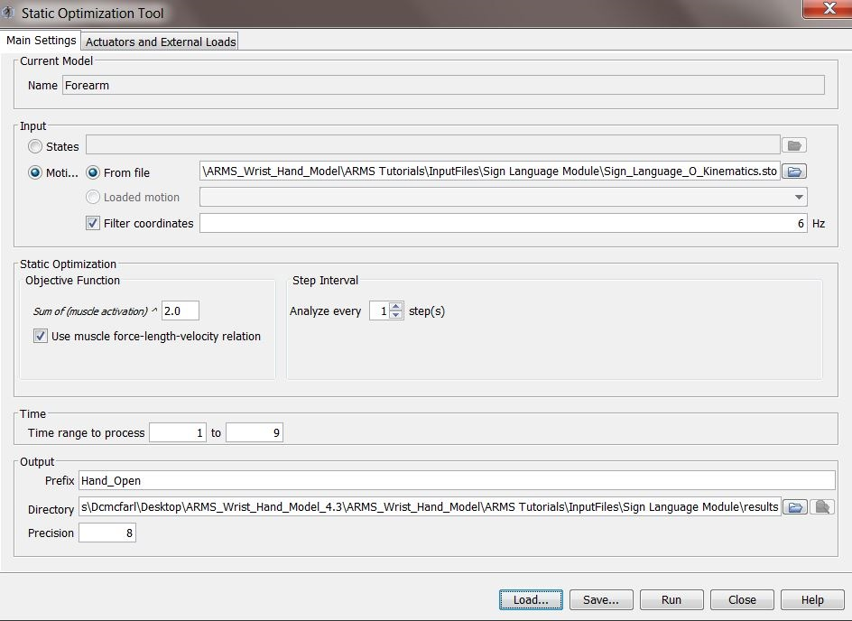

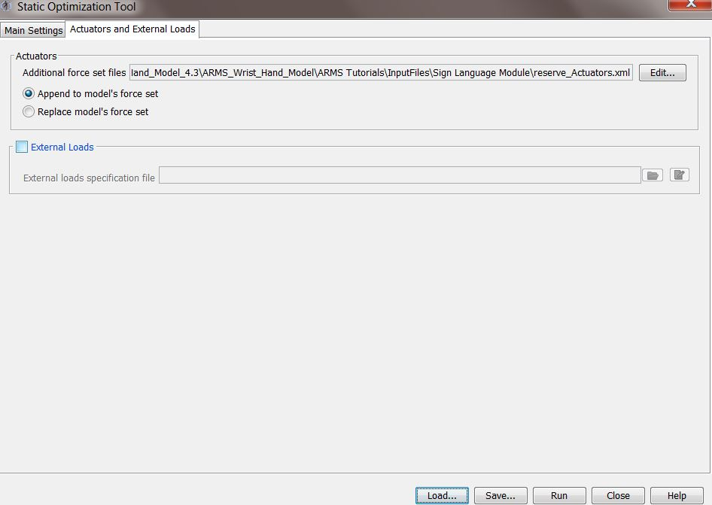

1. Specify Output Directory. Specify the Prefix and Directory for the output to whatever you choose.
2. Click Run to run the simulation.

**Comparison of outcomes**

Outcomes will be stored in “Hand_Open_StaticOptimization_activation.sto”. Load your results in Plot Tool by clicking “*y-Quantity*”. Select “*Load file*” and browse to your output. Select the muscle activation that you would like to evaluate and click *OK*. Compare results for ADPo, ADPt, APL, EDCI, EDCM, EDCR, EDCL, EPB, EPL, FDSI, FDSM, FDSR, FDSL, FPB, FPL, and all reserve actuators. Click “*x-Quantity*”, choose “*time”* and click *OK*. Click “*Add*” to plot the curve. Without closing the window, click “*y-Quantity*” again and this time load the corresponding comparison output file. Repeat the process above to plot the comparison curves. They should overlay. If you wish to save your plots, right click over the plot and select Export Image… from the menu; this will save the file as a .png image. If you prefer, you can plot the results in MATLAB or Excel. **Compare to:** *…\CompareResults\Sign Language Module*

# Module 3. Forward dynamic simulation of maximum grip strength

In this module, we perform forward dynamic simulations of maximum grip strength for several wrist postures. There are 7 simulations in this module; the 7 simulations are the strongest forward dynamic simulation for each of the 7 starting postures from the publication. This module uses the forward dynamics tool.

1. Once you have downloaded the **ARMS_Wrist_Hand_Model_3.3*.zip***, the models are in the folder:

…\ARMS Tutorials\InputFiles\Forward Grip Module

1. In OpenSim, load a model by going to file->Open Model… and then select the desired grip model. These grip models contain contact surfaces covering the proximal, middle, and distal phalanges of digits 2-5 (index, middle, ring, and little finger) as well as elliptical cylinder representing the dynamometer. In total, there are 13 OBJ files representing these contact surfaces. **Make sure that these OBJ files are in the same folder as the model file. There is a different model for each of the seven postures.** Models are named “*Grip_Model_posture.osim*” where posture is the name of the starting wrist posture (Table 1).These models are set with the correct starting posture and default activations for the muscle-tendon actuators for the simulation in that posture. Confirm that the correct model is loaded by comparing the set wrist posture in the coordinates tab against the values listed in Table 1. The coordinates for the thumb (cmc_flexion, cmc_abduction, mp_flexion, ip_flexion) should be locked; all other coordinates should be unlocked.
2. Open Forward Dynamics Tool. Tools-> Forward Dynamics…
3. In the Forward Dynamics tool, click the Load… button and load “setup.xml”

This file has made the following modifications to the default settings:

1. Set the time range for the forward simulation from 0 to 0.15 seconds.
2. Checked the Solve for equilibrium for actuator states box.
3. Loaded the ForceReporter and JointReaction Analyses
4. Load the desired controls file Controls_posture.sto where posture is the name of the desired initial wrist posture.

Once loaded the Forward Dynamics tool should look like the images below:

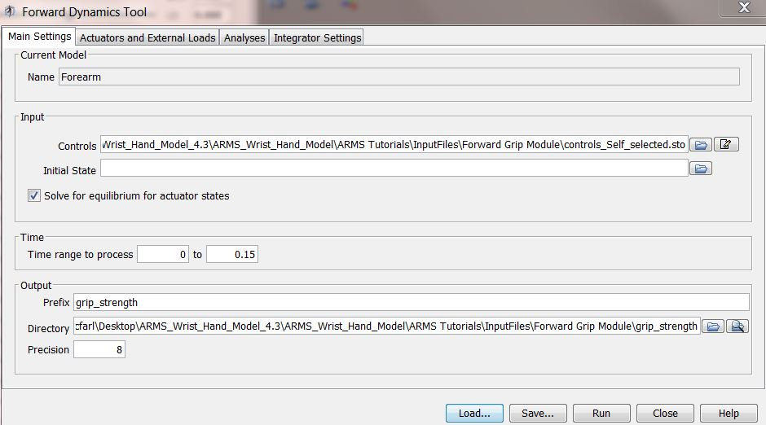

This example is for the Self_selected posture

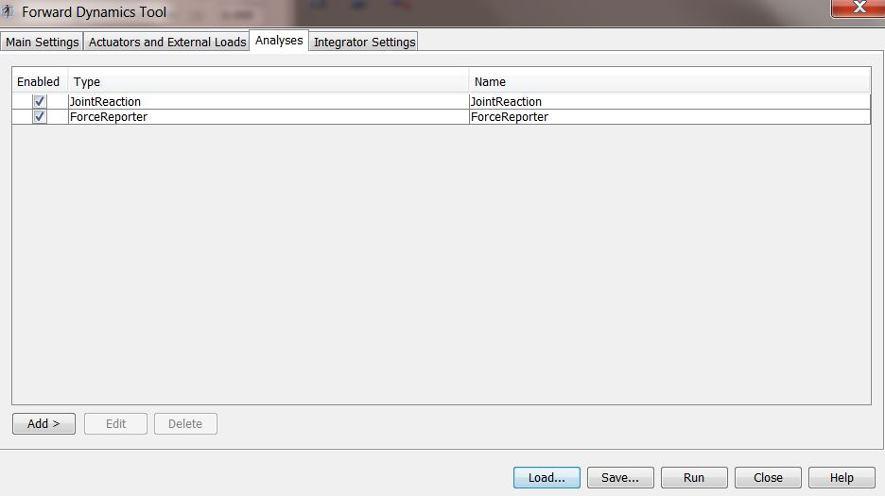

1. Specify Output Directory. Specify the Prefix and Directory for the output to whatever you choose.
2. Click Run to run the simulation.

**Table 1. Initial wrist posture for the forward dynamic maximum grip strength simulations.**

|  |  |  |  |  |  |  |  |
| --- | --- | --- | --- | --- | --- | --- | --- |
| Wrist Posture | Self-selected | Shifted in flexion | Shifted in extension | Shifted in radial | Shifted in ulnar | Neutral | Flexed |
| deviation | -35˚ | -15˚ | -47˚ | -32˚ | -29˚ | 0˚ | 10˚ |
| flexion | 7˚ | 5˚ | 5˚ | -1˚ | 17˚ | 0˚ | 5˚ |

**Comparison of outcomes**

Outcomes will be stored in MOT and STO files. Load your results in Plot Tool by clicking “*y-Quantity*”. Select “*Load file*” and browse to your output. Compare results for JointReaction_ReactionLoads file and the states file. For the JointReaction_ReactionLoads file plot GripForceJoint_on_thirdmc_in_thirdmc_fx, _fy, and _fz. For the states file, plot deviation and flexion. Select the reaction force or joint angle you want to plot and click *OK*. Click “*x-Quantity*”, choose “*time”* and click *OK*. Click “*Add*” to plot the curve. Without closing the window, click “*y-Quantity*” again and this time load the corresponding comparison output file. Repeat the process above to plot the comparison curves. They should overlay. If you wish to save your plots, right click over the plot and select Export Image… from the menu; this will save the file as a .png image. If you prefer, you can plot the results in MATLAB or Excel **.**

**Compare to:** *…\CompareResults\Forward Grip Module*

# Module 4. Optimal control theory maximum grip strength simulation

In this module, we use optimal control theory maximum grip strength in MATLAB using the OpenSim API. These simulations combine forward dynamic simulations of grip strength in OpenSim with a simulated-annealing optimization in MATLAB to determine activations that maximize grip force produced by the model while maintaining the initial wrist posture. The global optimization toolbox add-on must be installed in MATLAB to run the provided m-files.

1. Go to the folder

…\ARMS Tutorials\InputFiles\Grip Optimization Module

that contains the MATLAB files to run the optimal control theory simulations.

1. Check that the global optimization toolbox add-on is installed in MATLAB by typing ver into the command window.

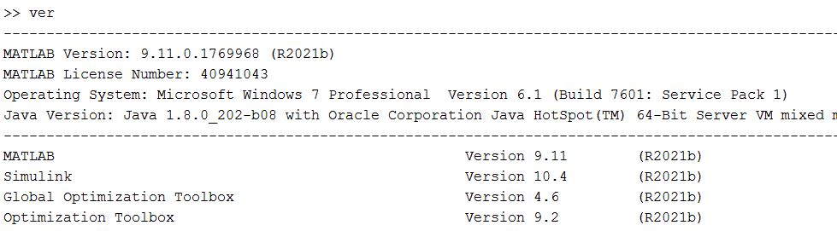

If you do not see Global Optimization Toolbox listed, click on add-on button in MATLAB and then search for and install the toolbox.

1. To set up the OpenSim API, follow the instructions on the following webpage:

<https://simtk-confluence.stanford.edu:8443/display/OpenSim33/Scripting+with+Matlab>

1. Make sure that the Grip_Model.osim file and the associated 13 OBJ files are in the same folder as the MATLAB M files GripForceObjectiveFunction.m and maximum_grip_force.m files. This folder should also contain a setup file (“setup.xml”) for the forward dynamic simulation and controls.sto that contains the activation to run the forward dynamic simulations.
2. GripForceObjectiveFunction.m is the objective function for the optimization.

Lines 1-68 updates the controls.sto file and the default activations in the .osim model to have the activations for the current step of the simulated-annealing optimization. This code will print a new controls file with the same name and a new model file (named default_activations.osim) with the default activations set. For more details, see the comments in the .m file.

Lines 70-73 runs the forward dynamics simulation

Line 75-89 calculates the grip force from the current step of the simulated annealing optimization. For more details, see the comments in the .m file. Make sure to update line 77 to reflect the path where the output file grip_strength_JointReaction_ReactionLoads.sto is saved. By default, this file will be saved to a new folder called grip_strength in the folder with the m-files.

Line 91-109 calculates the applied penalty term for any wrist movement. For more details, see the comments in the .m file. Make sure to update line 92 to reflect the path where the output file grip_strength_states_degrees.mot is saved. By default, this file will be saved to a new folder called grip_strength in the folder with the m-files. Make sure that you update lines 102&103 to reflect the initial posture of the Grip_Model.osim.

1. Open maximum_grip_force.m in MATLAB. This is the main file that setups up and runs the simulated-annealing optimization. This file can be directly run from MATLAB once the OpenSim API is set up for MATLAB. This is currently set up to run 1 iterations of the optimization. The number of iterations can be updated in line 31. Once ready to run the simulation click on run in MATLAB. When the simulation is complete it will save a variable called Results.mat to the folder with the .m files. Results.mat contains the activations and the objective function value for your optimal solution in variables named FVEC and FVAL respectively.

**Comparison of outcomes**

There are no comparison files for the optimization as simulated-annealing use randomization in the optimization and will not produce identical results between iterations.

# Module 5. Forward dynamic simulation of maximum pinch strength

In this module, we perform forward dynamic simulations of maximum pinch strength. This module uses the forward dynamics tool.

1. Once you have downloaded the **ARMS_Wrist_Hand_Model_3.3*.zip***, the models are in the folder:

…\ARMS Tutorials\InputFiles\Forward Pinch Module

1. In OpenSim, load a model by going to file->Open Model… and then select “*Pinch_Model.osim*”. This model does not include the intrinsic and extrinsic finger muscles. This model contains a point constraint between the thumbtip body and the ground body.
2. This model is set with the correct starting posture and default activations for the muscle-tendon actuators for the simulation. All the coordinates should be unlocked. The wrist degrees of freedom should be set to 0. CMC flexion should be set to -15˚, CMC abduction should be set to -20˚, mp_flexion should be set to 20˚, and ip_flexion should be set to 40˚.
3. Open Forward Dynamics Tool. Tools-> Forward Dynamics…
4. In the Forward Dynamics tool, click the Load… button and load “Pinch_Setup.xml”

This file has made the following modifications to the default settings:

1. Loaded the controls file Pinch_Controls.sto
2. Set the time range for the forward simulation from 0 to 0.2 seconds.
3. Checked the Solve for equilibrium for actuator states box.
4. Loaded the ForceReporter and JointReaction Analyses

Once loaded the Forward Dynamics tool should look like the images below:

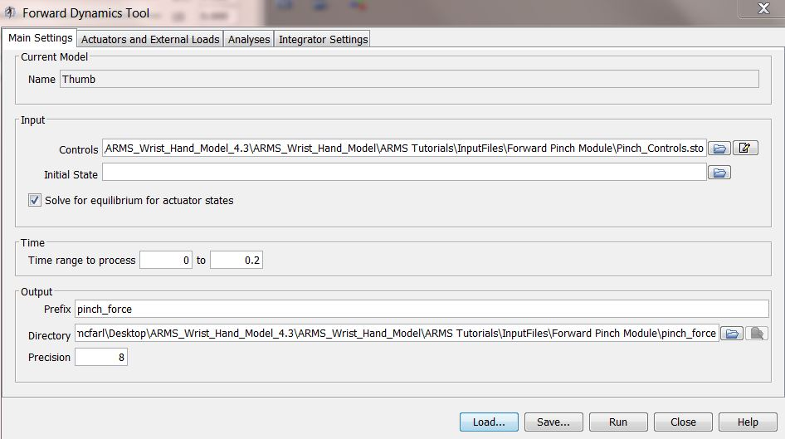



1. Specify Output Directory. Specify the Prefix and Directory for the output to whatever you choose.
2. Click Run to run the simulation.

**Comparison of outcomes**

Outcomes will be stored in MOT and STO files. Load your results in Plot Tool by clicking “*y-Quantity*”. Select “*Load file*” and browse to your output. Compare results for JointReaction_ReactionLoads file and the states file. For the JointReaction_ReactionLoads file plot thumbtip_on_Thumbtip_in_ground_fx, _fy, and _fz. For the states file, plot deviation and flexion. Select the reaction force or joint angle you want to plot and click *OK*. Click “*x-Quantity*”, choose “*time”* and click *OK*. Click “*Add*” to plot the curve. Without closing the window, click “*y-Quantity*” again and this time load the corresponding comparison output file. Repeat the process above to plot the comparison curves. They should overlay. If you wish to save your plots, right click over the plot and select Export Image… from the menu; this will save the file as a .png image. If you prefer, you can plot the results in MATLAB or Excel.

**Compare to:** *…\CompareResults\Forward Pinch Module*

# Module 6. Optimal control theory maximum pinch strength simulation

In this module, we use optimal control theory maximum pinch strength in MATLAB using the OpenSim API. These simulations combine forward dynamic simulations of pinch strength in OpenSim with a simulated-annealing optimization in MATLAB to determine activations that maximize pinch force produced by the model while maintaining the initial wrist posture. The global optimization toolbox add-on must be installed in MATLAB to run the provided m-files.

1. Go to the folder

…\ARMS Tutorials\InputFiles\Pinch Optimization Module

that contains the MATLAB files to run the optimal control theory simulations.

1. Check that the global optimization toolbox add-on is installed in MATLAB by typing ver into the command window.



If you do not see Global Optimization Toolbox listed, click on add-on button in MATLAB and then search for and install the toolbox.

1. To set up the OpenSim API, follow the instructions on the following webpage:

<https://simtk-confluence.stanford.edu:8443/display/OpenSim33/Scripting+with+Matlab>

1. Make sure that the Pinch_Model.osim file. This model contains a point constraint between the thumbtip body and the ground body. The model does not include the intrinsic and extrinsic finger muscles. This folder should also contain a setup file (“setup.xml”) for the forward dynamic simulation and controls.sto that contains the activation to run the forward dynamic simulations.
2. PinchForceObjectiveFunction.m is the objective function for the optimization.

Lines 1-54 updates the controls.sto file and the default activations in the .osim model to have the activations for the current step of the simulated-annealing optimization. This code will print a new controls file with the same name and a new model file (named default_activations.osim) with the default activations set. For more details, see the comments in the .m file.

Lines 56-59 runs the forward dynamics simulation

Line 61-87 calculates the pinch force and applies a penalty if the off-axes forces are greater than 17% of the force in the y-direction for the current step of the simulated annealing optimization. For more details, see the comments in the .m file. Make sure to update line 63 to reflect the path where the output file pinch_force_ForceReporter_forces.sto is saved. By default, this file will be saved to a new folder called pinch_force in the folder with the m-files.

Line 89-115 calculates the applied penalty term when the wrist moves beyond 5 degrees from the initial neutral wrist posture. For more details, see the comments in the .m file. Make sure to update line 90 to reflect the path where the output file pinch_force_states_degrees.mot is saved. By default, this file will be saved to a new folder called pinch_force in the folder with the m-files.

1. Open maximum_pinch_force.m in MATLAB. This is the main file that setups up and runs the simulated-annealing optimization. This file can be directly run from MATLAB once the OpenSim API is set up for MATLAB. This is currently set up to run 1 iterations of the optimization. The number of iterations can be updated in line 31. Once ready to run the simulation click on run in MATLAB. When the simulation is complete it will save a variable called pinch_force.mat to the folder with the .m files. pinch_force.mat contains the activations and the objective function value for your optimal solution in variables named FVEC and FVAL respectively.

**Comparison of outcomes**

There are no comparison files for the optimization as simulated-annealing use randomization in the optimization and will not produce identical results between iterations.